**GA “special “: Simulating a queuing system in a bank**

A queuing system consists of many servers that provide service of some sort to arriving customers. Customers who arrive to find all servers busy generally join one or more queues (lines) in front of the servers, hence the name queuing systems. There are several everyday examples that can be described as queuing systems, such as bank-teller service, computer systems, manufacturing systems, maintenance systems, communications systems and so on.

Components of a Queuing System: A queuing system is characterized by three components:

- Arrival process

- Service mechanism

- Queue discipline.

**Arrival Process**

Arrivals may originate from one or several sources referred to as the calling population.

The calling population can be limited or 'unlimited'. An example of a limited calling

population may be that of a fixed number of machines that fail randomly. The arrival

process consists of describing how customers arrive to the system. If Ai is the interarrival time between the arrivals of the (i-1)th and ith customers, we shall denote the mean (or expected) inter-arrival time by E(A) and call it (λ ); = 1/(E(A) the arrival frequency.

**Service Mechanism**

The service mechanism of a queuing system is specified by the number of servers

(denoted by s), each server having its own queue or a common queue and the probability

distribution of customer's service time. let Si be the service time of the ith customer, we

shall denote the mean service time of a customer by E(S) and µ = 1/(E(S) the service rate

of a server.

**Queue Discipline**

Discipline of a queuing system means the rule that a server uses to choose the next

customer from the queue (if any) when the server completes the service of the current

customer. Commonly used queue disciplines are:

FIFO - Customers are served on a first-in first-out basis.

LIFO - Customers are served in a last-in first-out manner.

Priority - Customers are served in order of their importance on the basis of their service

requirements. In this example use FIFO

**Classes needed**

1. **Queue as template class**
2. **CustomerType**
3. **ServerType**
4. **serverListType**
5. **waitingCustomerQueueType which inherits from queueType<customerType>**

**Simulation: technique for modeling behavior of natural and human-made systems.**

* **Problem to simulate model bank queue wait times**
  + **Average time customer waits to begin service from current single teller**
  + **Decrease in customer wait time with each new teller added**
* Modeling a queuing system: requirements
  + Number of servers, expected customer arrival time, time between customer arrivals, number of events affecting system
* Time-driven simulation
  + Clock implemented as a counter
  + Passage of time
    - Implemented by incrementing counter by one
* Run simulation for fixed amount of time
  + Example: run for 100 minutes
    - Counter starts at one and goes up to 100 using a loop

**The main program will implement the simulation of customers arrival, their service and waiting time**

**You can use the poisson distribution to simulate how frequent customers are added to the queues**

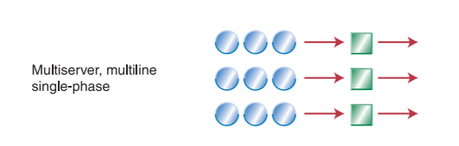

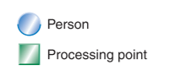

The output is to print the customers times: Arrival, waiting time, processing time , leaving the bank

**Example of output**

The simulation from minute 1 to 100

1. customer 1 arrives and join Queue 2

5 customer 2 arrives and join Queue3

7 customer 3 arrives join Queue1 and customer 4 arrives and join queue3

……

While keep receiving customers assign customers to server based on their type ..

After processing print all the times

Customer 1 served by server 2

Arrival time:

Waiting time:

Processing time:

Leaving the bank at x minutes